Chapter 4 Reacting masses,chemical equations name: class:
1.了解relative mass的定义（跟C-12质量的ratio）
Relative atomic mass (Ar) : the average mass of its isotopes, compared to the 1/12 the mass of the ¹²C atom.
1. The relative atomic mass of chlorine is 35.5.
When calculating relative atomic mass, which particle is the mass of a chlorine atom compared to? （ ）
A a neutron
B a proton
C an atom of carbon-12
D an atom of hydrogen-1

2. The relative atomic mass of chlorine is 35.5.
When calculating relative atomic mass, which particle is the mass of a chlorine atom compared to? （ ）
A a neutron
B a proton
C an atom of carbon -12
D an atom of hydrogen -1

2.掌握如何计算物质的relative molecular mass.
1. A compound has the formula CH₃CO₂H
How should the relative molecular mass, Mr of this compound be calculated?（ ）
A. (12 + 1 + 16)
B. (3(12 + 1) + 2(12 + 16) + 1)
C. (4 × 12) + (2 × 1) + 16)
D. (2 × 12) + (4 × 1) + (2 × 16)

2. The table shows the numbers of atoms present in the formula of some compounds.
Which row is not correct? （ ）
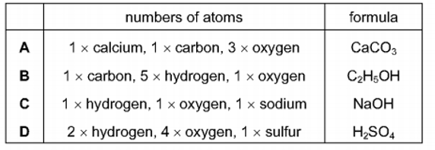
3. Iron forms an oxide with the formula Fe₂O₃.
What is the relative formula mass of this compound? （ ）
A 76 B 100 C 136 D 160
4. What is the relative formula mass, Mr of CaCO₃? （ ）
A 50 B 68 C 100 D 204

3.掌握state symbol的意义.
(s) for solid (l) for liquid (g) for gas
(aq) for aqueous solution (a solution in water)
1. The equation for the reaction between barium chloride solution and dilute sulfuric acid is shown.
BaCl₂ + H₂SO₄ → 2HCl + BaSO₄
Which row shows the state symbols for this equation? （ ）
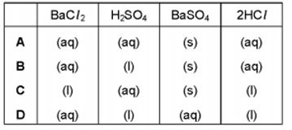
2. The equation represents the reaction between solid magnesium oxide and dilute hydrochloric acid to form magnesium chloride and water.
MgO + 2HCl → MgCl₂ + H₂O
Which row shows the state symbols for hydrochloric acid, magnesium chloride and water? （ ）
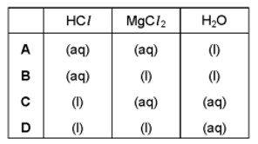

4.掌握如何配平chemical equation.
1.Which equations are balanced? （ ）
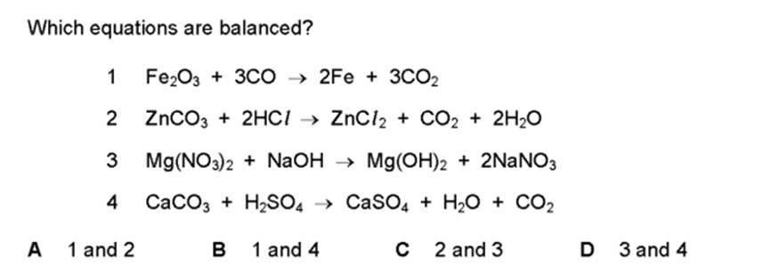

2. The equation for the reaction between phosphorus and oxygen is shown.
xP₄ + yO₂ → z P₂O₅
Which values of x, y and z balance the equation? （ ）
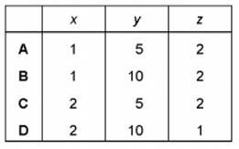

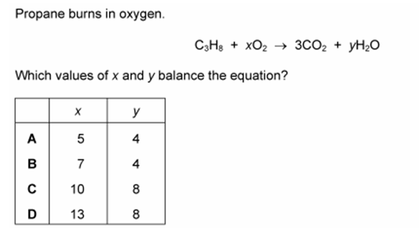
3. Propane burns in oxygen.

Which values of x and y balance the equation? （ ）
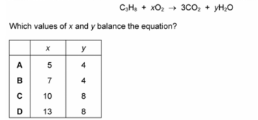

4. Ethyl methanoate,HCOOC2H5, burns in excess oxygen to produce carbon dioxide and water.The equation is shown.
2 HCOOC₂H₅ + xO₂ → 6CO₂ + 6H₂O
What is the value of x?
A 2
B 7
C 9
D 18

